**Taking Backup and Restoring data in Mongo database:**

Point to the bin folder in the command line

*Use the below command to take Backup:*

mongodump.exe --host petraitis.info --port 27017

This creates a directory called dump with all the available databases backed up. The data backed up will be in BSON/JSON format.

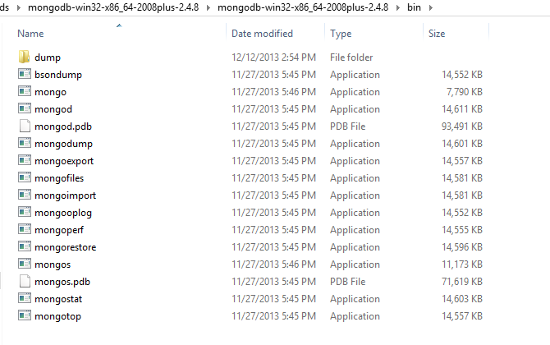

To restore the data use the below command (pointed to bin folder)

mongorestore.exe --host petraitis.info --port 27017

This restores the database automatically.

